Solid-drawn weldless netting
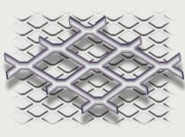 |  | Material- coldly pull sheet of low carbon steel or stainless steel, thickness 0.7-1.2mm, width-1000mm, length- 1500-2500mm. Netting can have another dimension of mesh and different step of list feeding. Solid -drawn netting could be covered by PVC

Designation | Dimension of big diagonal |  | Dimension of small diagonal |  | Step of listfeeding,  mm
Designation | mm | inch | mm | inch | Step of listfeeding,  mm
SDWN-15 | 15 | 0.59 | 6.0 | 0.24 | 1.5
SDWN-20 | 20 | 0.79 | 7.5 | 0.30 | 1.6
SDWN-25 | 25 | 0.98 | 9.0 | 0.35 | 2.3
SDWN-30 | 30 | 1.18 | 11.5 | 0.45 | 2.5
SDWN-40 | 40 | 1.57 | 15.5 | 0.61 | 3.0

